9.

(a)

library(ISLR)  
auto=Auto  
plot(auto)

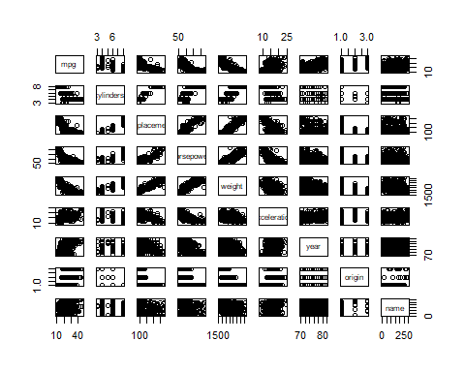

(b)

auto=auto[,-9]  
cor(auto)

## mpg cylinders displacement horsepower weight  
## mpg 1.0000000 -0.7776175 -0.8051269 -0.7784268 -0.8322442  
## cylinders -0.7776175 1.0000000 0.9508233 0.8429834 0.8975273  
## displacement -0.8051269 0.9508233 1.0000000 0.8972570 0.9329944  
## horsepower -0.7784268 0.8429834 0.8972570 1.0000000 0.8645377  
## weight -0.8322442 0.8975273 0.9329944 0.8645377 1.0000000  
## acceleration 0.4233285 -0.5046834 -0.5438005 -0.6891955 -0.4168392  
## year 0.5805410 -0.3456474 -0.3698552 -0.4163615 -0.3091199  
## origin 0.5652088 -0.5689316 -0.6145351 -0.4551715 -0.5850054  
## acceleration year origin  
## mpg 0.4233285 0.5805410 0.5652088  
## cylinders -0.5046834 -0.3456474 -0.5689316  
## displacement -0.5438005 -0.3698552 -0.6145351  
## horsepower -0.6891955 -0.4163615 -0.4551715  
## weight -0.4168392 -0.3091199 -0.5850054  
## acceleration 1.0000000 0.2903161 0.2127458  
## year 0.2903161 1.0000000 0.1815277  
## origin 0.2127458 0.1815277 1.0000000

(c)

attach(auto)  
mo=lm(mpg~.,data=auto)  
summary(mo)

##   
## Call:  
## lm(formula = mpg ~ ., data = auto)  
##   
## Residuals:  
## Min 1Q Median 3Q Max   
## -9.5903 -2.1565 -0.1169 1.8690 13.0604   
##   
## Coefficients:  
## Estimate Std. Error t value Pr(>|t|)   
## (Intercept) -17.218435 4.644294 -3.707 0.00024 ***  
## cylinders -0.493376 0.323282 -1.526 0.12780   
## displacement 0.019896 0.007515 2.647 0.00844 **   
## horsepower -0.016951 0.013787 -1.230 0.21963   
## weight -0.006474 0.000652 -9.929 < 2e-16 ***  
## acceleration 0.080576 0.098845 0.815 0.41548   
## year 0.750773 0.050973 14.729 < 2e-16 ***  
## origin 1.426141 0.278136 5.127 4.67e-07 ***  
## ---  
## Signif. codes: 0 '***' 0.001 '**' 0.01 '*' 0.05 '.' 0.1 ' ' 1  
##   
## Residual standard error: 3.328 on 384 degrees of freedom  
## Multiple R-squared: 0.8215, Adjusted R-squared: 0.8182   
## F-statistic: 252.4 on 7 and 384 DF, p-value: < 2.2e-16

Yes, there is a relationship between the predictors and the response because we can see t-hat the p-value of the parameter is extremely small, which means there exists the signific-ant relationship.

(ii)

Displacement, weight, year and origin.

(iii)

As time goes by, the mpg increase.

(d)

par(mfrow=c(2,2))  
plot(mo)

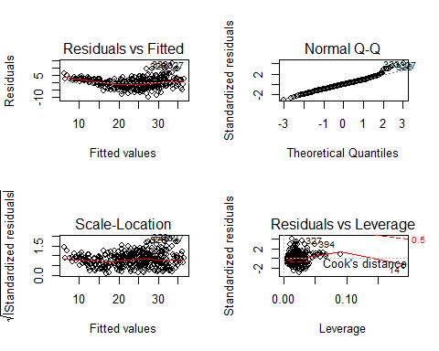

It seems that the point 14 has high leverage, but it has no large outlier in this model.

(e)

newmodel=lm(mpg~cylinders*weight+displacement*horsepower)  
summary(newmodel)

##   
## Call:  
## lm(formula = mpg ~ cylinders * weight + displacement * horsepower)  
##   
## Residuals:  
## Min 1Q Median 3Q Max   
## -11.1157 -2.1817 -0.3764 1.8410 16.9231   
##   
## Coefficients:  
## Estimate Std. Error t value Pr(>|t|)   
## (Intercept) 5.917e+01 4.316e+00 13.708 < 2e-16 ***  
## cylinders -6.587e-01 1.045e+00 -0.631 0.52872   
## weight -5.271e-03 1.938e-03 -2.720 0.00682 **   
## displacement -7.364e-02 1.561e-02 -4.718 3.34e-06 ***  
## horsepower -1.898e-01 2.513e-02 -7.554 3.11e-13 ***  
## cylinders:weight 3.958e-04 2.781e-04 1.423 0.15550   
## displacement:horsepower 4.499e-04 8.028e-05 5.604 3.99e-08 ***  
## ---  
## Signif. codes: 0 '***' 0.001 '**' 0.01 '*' 0.05 '.' 0.1 ' ' 1  
##   
## Residual standard error: 3.859 on 385 degrees of freedom  
## Multiple R-squared: 0.7593, Adjusted R-squared: 0.7555   
## F-statistic: 202.4 on 6 and 385 DF, p-value: < 2.2e-16

We choose the interaction predictors randomly.

As we can see in the summary, the displacement*horsepower is statistically significant.

(f)

trans=lm(sqrt(mpg)~sqrt(horsepower)+I((weight)^2)+log(year),data=auto)  
summary(trans)

##   
## Call:  
## lm(formula = sqrt(mpg) ~ sqrt(horsepower) + I((weight)^2) + log(year),   
## data = auto)  
##   
## Residuals:  
## Min 1Q Median 3Q Max   
## -0.97825 -0.23980 -0.00936 0.19391 1.16931   
##   
## Coefficients:  
## Estimate Std. Error t value Pr(>|t|)   
## (Intercept) -1.554e+01 1.761e+00 -8.822 < 2e-16 ***  
## sqrt(horsepower) -1.055e-01 2.075e-02 -5.087 5.67e-07 ***  
## I((weight)^2) -7.814e-08 6.528e-09 -11.970 < 2e-16 ***  
## log(year) 5.110e+00 3.931e-01 12.999 < 2e-16 ***  
## ---  
## Signif. codes: 0 '***' 0.001 '**' 0.01 '*' 0.05 '.' 0.1 ' ' 1  
##   
## Residual standard error: 0.3432 on 388 degrees of freedom  
## Multiple R-squared: 0.8188, Adjusted R-squared: 0.8174   
## F-statistic: 584.4 on 3 and 388 DF, p-value: < 2.2e-16

The transformed predictors are all statistically significant, and the $R^{2}$ of this model is ov-er 0.8, so it can highly explain the information.